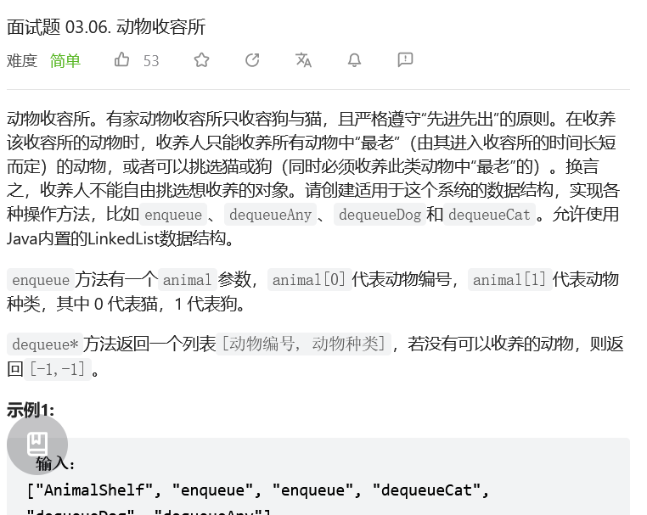

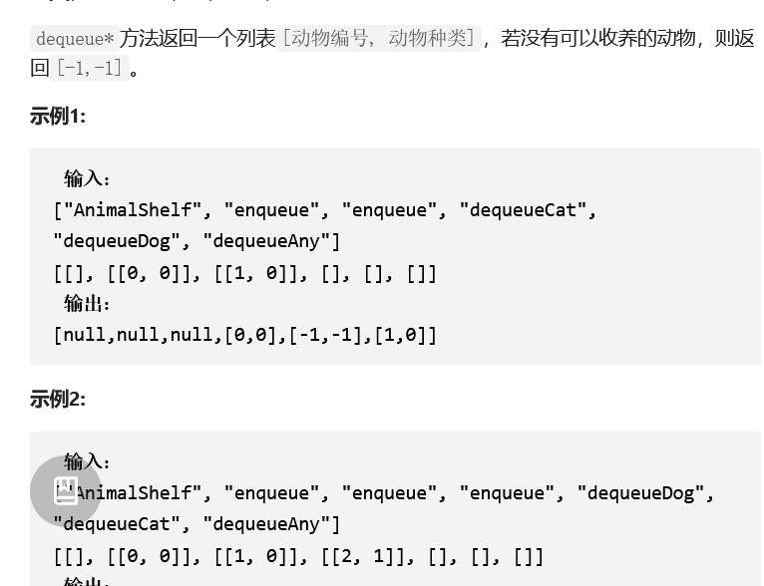

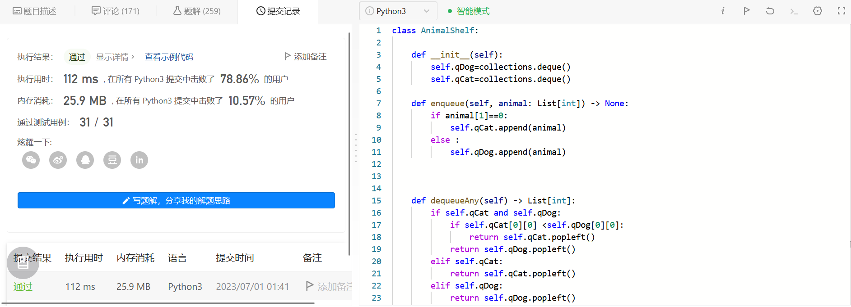
class AnimalShelf:

def __init__(self):
self.a = [deque(),deque()]

def enqueue(self, animal: List[int]) -> None:
self.a[animal[1]].append(animal)

def dequeueAny(self) -> List[int]:
if self.a[0] and self.a[1]:
return self.a[0][0][0] <self.a[1][0][0] and self.a[0].popleft() or self.a[1].popleft()
return self.a[0] and self.dequeueCat() or self.dequeueDog()

def dequeueDog(self) -> List[int]:
return self.a[1] and self.a[1].popleft() or [-1,-1]

def dequeueCat(self) -> List[int]:
return self.a[0] and self.a[0].popleft() or [-1,-1]

# Your AnimalShelf object will be instantiated and called as such:
# obj = AnimalShelf()
# obj.enqueue(animal)
# param_2 = obj.dequeueAny()
# param_3 = obj.dequeueDog()
# param_4 = obj.dequeueCat()

